National Salt Awareness Day 2003
The fourth National Salt Awareness Day on Wednesday 29th January 2003 was launched by CASH (Consensus Action on Salt and Health).
A Media event at the House of Commons marked the day, with over 90 guests in total, including journalists, MP's, representatives from the major supermarkets, industry, chefs and health professionals. This year's focus was children's diets. The high salt intake of children's diets was highlighted, as children are consuming as much salt as adults, demonstrating where this came from and offering suggestions for improving the diets of children.
Hosted by Labour MP for St Albans, Kerry Pollard, the guest speakers included,
- Graham MacGregor (Professor of Cardiovascular Medicine at St George's Hospital in London),
- Annabel Karmel (Leading Author on Children's Nutrition),
- Richard Ali (Director of Food Policy at the British Retail Consortium),
- Anton Edelman (Head chef of the Savoy)
- Emma Fluck (Project Co-ordinator for CASH).
A tea time low salt buffet was also available throughout the event.
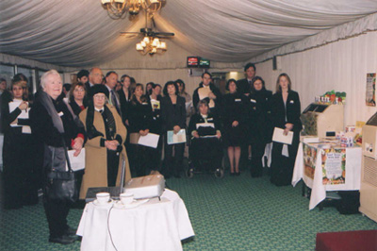
Some attendees of National Salt Awareness Day in the Terrace Marque
Presentations
Professor Graham Macgregor.
He talked about the importance of reducing salt in everyone's diets because of the many people dying of heart attacks and strokes in the UK. Around 50% of people in the room would suffer from either a heart attack or stroke if nothing was done to reduce the amount of salt in foods.
He highlighted the fact that children were eating as much salt as adults and drew everyone's attention to some examples of food products that children typically eat e.g. lunchables.
Annabel Karmel,
gave a more personal speech about her experiences which led to her career in children's nutrition. "Enabling children to eat less salt is vital because eating habits and tastes are formed in childhood." She believes that the liking for salt and salty foods is a learned taste preference and if children have little salt then they will not miss it in their diets.
Richard Ali,
talked about the BRC's members and how they are at the forefront of developing and implementing policies to ensure minimum salt usage across all their processed range. "Food retailers have therefore welcomed the Government's call for all of the food chain to minimise the use of salt without compromise to food safety and consumer acceptability".
Anton Edelman,
Anton said that as a chef, a little salt helps to bring out the flavour of our food and our body needs a little. He also pointed out "I think that using too much salt will cover up the natural flavours of your food and in a restaurant very often too much salt covers up bad cooking."
He went on to say that "Food without herbs and spices is like a language without grammar".
Emma Fluck,
went through the findings of our salt survey conducted in 5 schools, on 367 pupils, displaying graphs from the results. The reason for carrying out the survey was to find out children's attitudes towards salt and their understanding of the issues surrounding excessive salt intake. The most striking findings were that most pupils ranked the saltiest foods as least salty. Crisps were ranked as the saltiest when in fact cornflakes were, so this highlights that children aren't aware of the hidden salt levels.
"There was a good understanding of the main health implications of salt -96% knew that excessive intake could lead to heart health problems." In conclusion to what was found "This points to a need for the food industry to act to ensure that children do not consume too much salt by eating the foods they enjoy. Action is also needed to ensure that when children do eat processed foods, the label provides clear information with which children can easily find out how much salt they are eating."
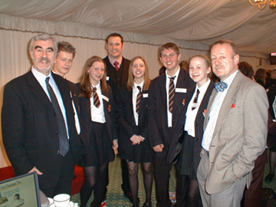
MP Kerry Pollard (far left), Anton Edelman (far right), some pupils and form teacher from Sandringham school in St Albans.
MP Kerry Pollard (far left), Anton Edelman (far right), some pupils and form teacher from Sandringham school in St Albans.
The low salt buffet tea
There was a fantastic low salt tea provided by the caterers at the House of Commons. This included tea, coffee, open sandwiches, mini quiches, no salt crisps and vegetable chips, lamb kebabs, mini pizza with low salt toppings, scones, carrot cake and a wonderful fruit platter display.
The supermarkets and stands
There were 8 stands including the main supermarkets, Lo Salt with the Veggie Gang. These all displayed literature about the work they have been doing on salt reduction, along with examples of food products they produce and their labelling.
Resources
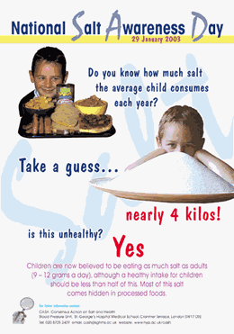  Poster used to highlight the day | The press pack included the background evidence document on the scientific research that has been carried out that links children's diets with how much salt they consume and the effects on their health.  Typical foods eaten by children, which was based on the National Diet and Nutrition survey carried out on young people aged 4 to 18 years.  A salt challenge leaflet, which can be used for both children and adults but is a way for them to find out how much salt they consume according to some typical foods and then gaining some points, which are added up to give you a salt status. There was also an 8 page cookery leaflet written by Annabel Karmel, diet scenarios for 6 children's diets. The press release, the CASH leaflet, summary of the findings from the salt survey carried out on children aged 12-16 years, the CASH 4 educational leaflets and a list of organisations that are making salt reductions.

Sponsors
We had various sponsors including, Marks and Spencer's, Tesco's, The Co-op and Waitrose and the British Heart Foundation.

