**National Salt Awareness Day 2004 - Evaluation**

**The fifth National Salt Awareness Day on Wednesday 28th January 2004 was launched by CASH (Consensus Action on Salt and Health)**.

A Media event at the House of Commons marked the day, with over 100 guests in total, including journalists, MPs, representatives from the major supermarkets, industry, chefs and health professionals. This year's focus was on consumer perceptions of salt and salt labelling.

Hosted by Labour MP for St Albans, Kerry Pollard, the guest speakers included,

**Melanie Johnson MP**, Minister for Public Health  
**Professor Graham MacGregor**, Chairman of CASH  
**Deirdre Hutton**, Chair of the National Consumer Council  
**Sir John Krebs,** Chair of the Food Standards Agency

A low salt buffet lunch was also available throughout the event.

**Presentations**

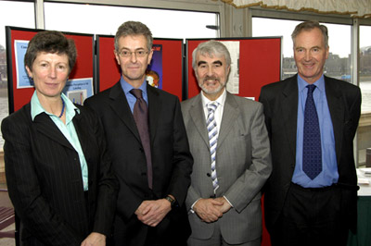  
From left, Deirdre Hutton, Sir John Krebs, Kerry Pollard MP and Professor Macgregor

**Melanie Johnson MP**

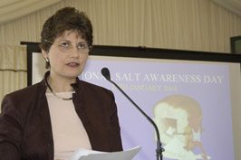She started her presentation talking about the significant health risks surrounding a high salt intake. *"****Salt contributes 50,000 deaths from stroke and 100,000 deaths from CHD. If we were to reduce intakes from the current 9 to 6g a day, it is estimated to reduce the incidence of hypertension by 17%, CHD by 6% and stroke by 15%."***

She then spoke about the government's commitment and the work of the Department of Health's Food and Health Action Plan. This pulls together all nutrition related activities and addresses issues on food production, manufacture, production, access to healthier food choices and consumer information. Education is another key area as we all have a responsibility to educate consumers. Increasing awareness amongst the population of the link between salt, high blood pressure and heart disease.

She then went on to talk about action to date*. "****The current situation is not acceptable - so much more can be and must be done and we all have a role to play. We have heard the enormous health risks of high salt intake. Salt is a hidden killer and even if consumers want to reduce salt, there is only so much they can do as 75% of salt is from processed foods."*** Therefore she has requested action plans from food manufacturers by 27 February 2004 on what they are doing to address this important issue.

**Professor Graham Macgregor.**

He talked about the importance of reducing salt in everyone's diets because of the many people dying of heart attacks and strokes in the UK. ***"At the age of twenty, 20% have raised blood pressure, at fifty, 50% and at seventy, 70%."***

He went on to talk about salt in food and that 80% is hidden in processed foods. ***"Consumers did not ask for all this salt to be surreptitiously added by the food industry. The time has now come for the food industry to recognise its ethical responsibility for the good health of its consumers and start reducing the very high and unnecessary salt concentration of their foods."***

***"A 10% reduction in the salt concentration across the whole food chain could be done tomorrow and would prevent over 12,000 stroke and heart attack event a year. Further reductions of 10% could be made every year and the target of 5 to 6g/day could be reached within six years."***

**Deirdre Hutton**

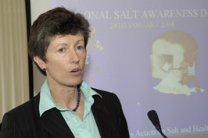Deirdre Hutton talked about salt from the consumer perspective. Firstly she congratulated CASH on its persistent campaign throughout the years and thanked CASH for raising its profile considerably.

On the consumer front she emphasized the key problem as confusion.

***"The key issue is confusion. I find it astonishing that it is still ok to label something called sodium on the packet when actually we don't have a clue how the sodium relates to salt or how it relates to how much we should be eating. How are we supposed to look after ourselves if you don't give us the information?"***

She also touched on health education and the lack of it emphasising the need for more education by the government and the Food Standards Agency.

**Sir John Krebs**

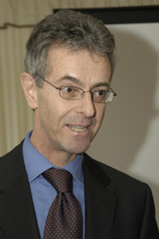Sir John talked about the work of the Food Standards Agency and food manufacturer's responsibilities.

***"The FSA is in discussions with different parts of the food industry on what reductions they can make in processed food. The key thing here is that as far as we are concerned the actions that we are interested in are the ones that are verifiable with real data rather than the ones which are claimed, or asserted or have gone missing."***

In terms of where we are up to; ***" There are steps in the right direction but remember they are steps on a journey from 9.5 g down to 6g per day. The metaphor I use - if you think that as a journey from London to Edinburgh, the proposals we've got on the table so far, take us to just inside the M25 and we've got a hell of a long way to go, but we are moving in the right direction."***

**The low salt buffet lunch**

There was a fantastic low salt lunch provided by the caterers at the House of Commons. This included tea, coffee, open sandwiches, salt free crisps and vegetable chips, lamb kebabs, mini pizza with low salt toppings, scones, carrot cake and a wonderful fruit platter display.

**The Supermarkets and stands**

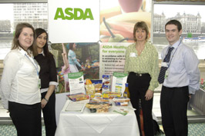  
There were eight stands including the main supermarkets (Asda, Co-op, Marks and Spencer's, Safeway, Somerfield, Tesco, Waitrose) and Losalt. All were displaying literature on their salt reduction programmes along with examples of packaging.