Supporting Events 2005
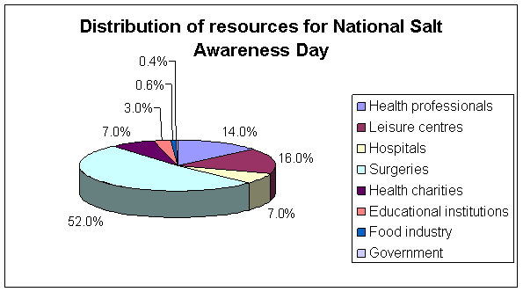
1066 complimentary health professional packs were distributed at the end of 2004 throughout the UK, including Ireland, Wales and Scotland. Packs were sent to health professionals (including dietitians, nutritionists and health promotion units) 14%, leisure and fitness centres (16%), hospitals (7%), GP surgeries (52%), health charities (7%), educational institutions (3%), food industry (0.6%) and government organisations (0.4%).
Below are some examples of how the resources were used and what events took place on the day.
The Catering People Ltd at Portol, Vanessa Levell
"For the whole day no added salt will be used in food provided in the staff canteen. Posters, leaflets, menu information, low salt sachets will be available on the day".
Heart Research Fund, Ridings Shopping Centre, Wakefield, Denise Armstrong
"There will be a heart research display related to salt awareness, with posters and leaflets. The lifestyle officer will be available to give nutritional advice and a food advisor will be giving samples of the Marks and Spencer's count on us or eat well range and also to explain the new labelling system."
"Heart Research is committed to the prevention of heart disease through education and awareness of issues such as the link between salt and high blood pressure."
The James Cook University Hospital, Middlesbrough, Andrea Evans
"A display of resources including leaflets, factsheets, salt models and a food model display will take place in the diabetes care centre, cardio outpatients and the stroke unit"
Village Hall in Cirencester and Stroud, Dorothy Turner
"Salt Awareness will be the topic in a number of healthy lifestyle 60+ classes"
The Clee Medical Centre, Grimsby, Lynne Donovan
"There will be a display of information including posters and leaflets relating to health,
plus an article will be written to go in the Grimsby Evening Telegraph to coincide with the end of January"
Adswood Sure Start Centre, Stockport, Clare Barrington
"The sure start food and health team will be holding a raising awareness session in the foyer of the children's centre"
"Reducing salt together with reducing fat consumption and increasing our consumption of fruit and vegetables are ways we can improve the health of our children"
Craigavon Leisure Centre, Lurgan, Joy Dunlop
"We will be holding a health fair on salt awareness to an elderly group (Craigavon Stroke Scheme). Also health checks will be provided, these include; blood pressure, blood sugar testing, stress awareness, smoking and alcohol advice".

